**PROJECT PROPOSAL**

**PROJECT:** *KEEP-IT-SIMPLE-STUPID* *DATE GENERATOR*

**TEAM MEMBER:** Luís Fernando Cely, D.J. Gilmore, Eric Nuanes, Stenio Pereira

**PROJECT DESCRIPTION:** A date planning application for those who can’t plan a date. It assists users in planning stay home date and go out date. The app will give entertainment, restaurant, drink, and gift suggestions to its users while taking into account their budget and location .

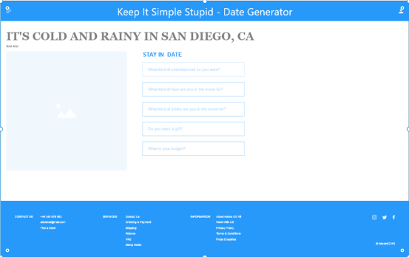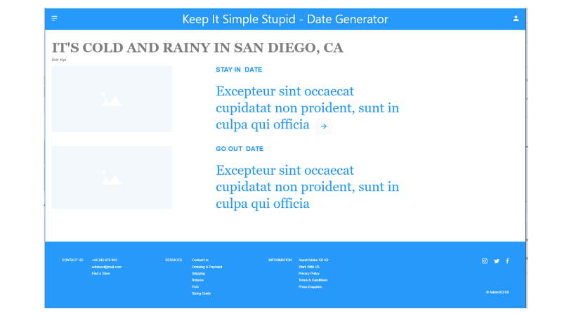

**API’s to be used:**

* Weather – DJ (DONE)
* Yelp – ~~DJ~~ – Stenio
* Eventful - Fernando
* ~~Fandango - DJ~~
* Absolut Drinks - Fernando
* OpenTable – Eric Nuanes
* Gifts – Eric Nuanes
* ~~Spotify – Stenio &~~ F.E. Page Layouts

**BASIC Breakdown of the tasks:**

* DEFINE THE APPLICATION’S GOAL
* WIREFRAME AND LAYOUT THE SITE STRUCTURE
* DEVELOP PSEUDO-CODE
* FRONT-END DEVELOPMENT
* SCRIPTING & BACK-END DEVELOPMENT
* TESTING & QC.

Alternate Ideas: Date Roullette – develop random date ideas.